‘It hadn’t occurred to me to listen to my baby and give him space to talk.’  (Baby Peep Parent)  ‘I’ve discovered how much my child learns through play.’ (Toddler Peep Parent)  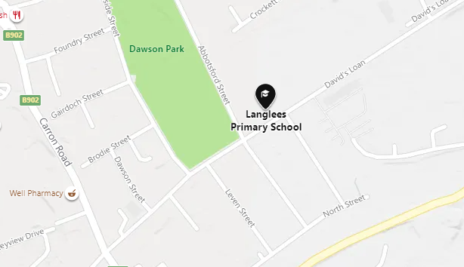  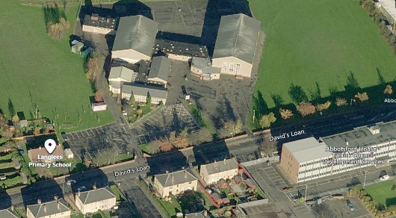  We are the building to the front left of the primary school.  Langlees Early Learning and Childcare Centre  Davids Loan  Langlees  Falkirk  FK2 7RG  Tel 01324 508673  langleeselccentre@falkirk.gov.uk |  |  |  |  | supporting parents and children  to learn together  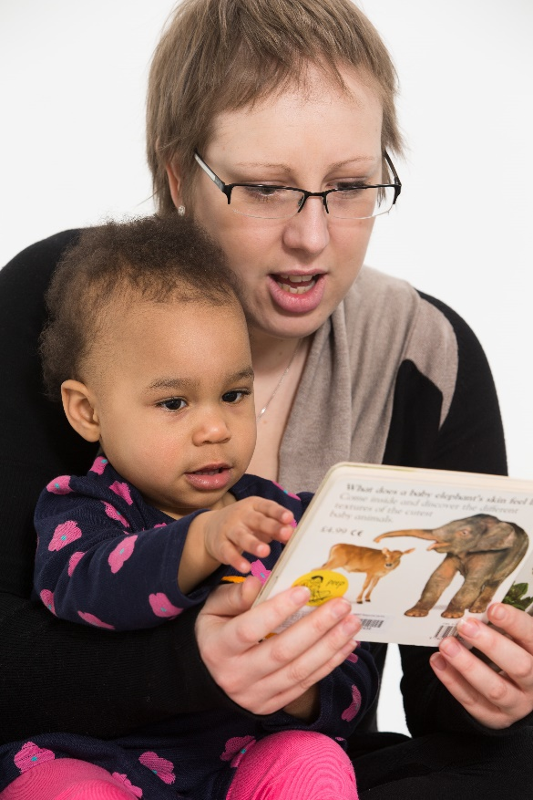 |   
  
  The Peeple Centre
  PO Box 1404
  Oxford OX4 6XW
  Peeple is a charity that trains practitioners and works with families - enhancing children’s development by making the most of play and learning opportunites in everyday life
  Stay in touch
  facebook.com/peeplecentre
  @PeepleCentre
  www.peeple.org.uk
  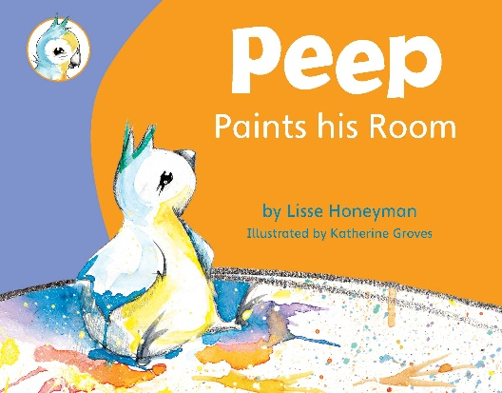
  Welcome to your
  Peep group:
  Langlees ELC Centre
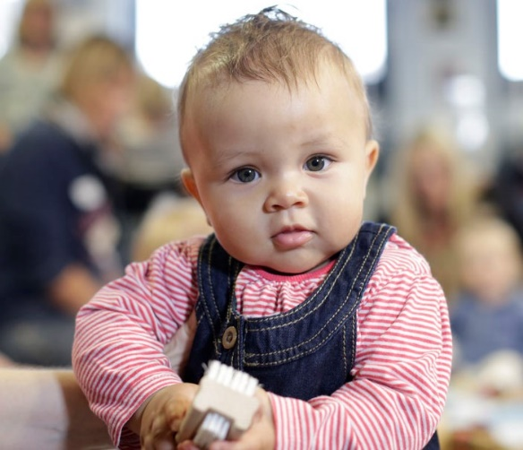  Peep supports all parents and carers with children from pregnancy to school, in encouraging their child’s learning and development.  You can make a real difference just by talking, playing, singing and sharing books or activities together.  Come along - you and your baby or child can make friends, share ideas and have fun through singing, story and activities.. |  |  | 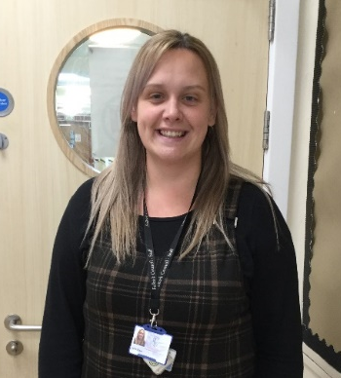  My Peep group is run by:  Laura Kippen  Senior Early Years Officer  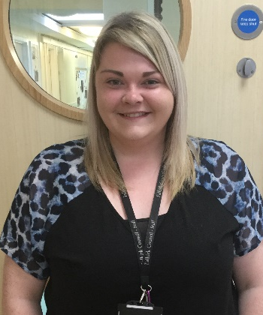  Keira Rollo  Early Years Officer  It’s helpful if you could let us know if you can’t make it any week – tel:01324 508673 |  |  | 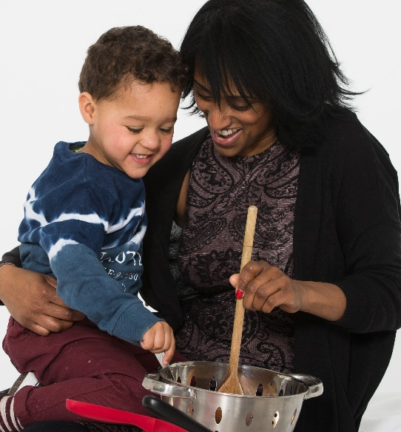  My Group meets at:  Langlees ELC Centre  on: Thursday  at: 10am Bubble 1  and 10.45am Bubble 2

